Experiment No.-1

**Aim:** Write the programs for Build in Data Types

**Program Code:**

# Integer

x = 42

print(x.bit_length())  # Number of bits required to represent the number in binary

# Float

y = 3.14

print(round(y))  # Rounds the number

# Complex

z = 2 + 3j

print(z.real)  # Real part

print(z.imag)  # Imaginary part

**Output:**

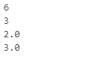

**Program Code:**

# String Methods

s = "Python"

print(s.upper())  # Converts to uppercase

print(s.lower())  # Converts to lowercase

print(s.startswith("Py"))  # Checks if it starts with "Py"

print(s.replace("Py", "My"))  # Replaces substring

**Output:**

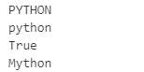

**Program Code:**

# List Methods:

lst = [1, 2, 3]

lst.append(4)  # Adds an element

lst.remove(2)  # Removes an element

lst.reverse()  # Reverses the list

print(lst)     # Output: [3, 1, 4]

**Output:**



**Program Code:**

# Tuple Methods: Tuples are immutable but have some methods:

t = (1, 2, 3, 1)

print(t.count(1))  # Counts occurrences of 1

print(t.index(2))  # Finds index of 2

**Output:**



**Program Code:**

# Range

r = range(1, 10, 2)  # Start=1, Stop=10, Step=2

print(list(r))  # Output: [1, 3, 5, 7, 9]

**Output:**



**Program Code:**

# Dictionary Methods: dict – Dictionary (e.g., {"key": "value"})

d = {"a": 1, "b": 2}

print(d.keys())   # Returns keys

print(d.values()) # Returns values

print(d.get("a")) # Returns the value for key "a"

d.update({"c": 3}) # Adds a new key-value pair

print(d)          # Output: {'a': 1, 'b': 2, 'c': 3}

**Output:**

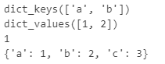

**Program Code:**

# Set Methods: Unordered, mutable collection of unique elements (e.g., {1, 2, 3})

s = {1, 2, 3}

s.add(4)          # Adds an element

s.remove(2)       # Removes an element

print(s.union({5, 6}))  # Combines sets

print(s.intersection({3, 4, 5}))  # Finds common elements

**Output:**



**Program Code:**

# bool – Boolean (e.g., True, False)

a = True

b = False

print(a and b)  # Logical AND

print(a or b)   # Logical OR

print(not a)    # Logical NOT

**Output:**



**Program Code:**

b = b"Python"

print(b.decode())  # Converts to string

ba = bytearray(b)

ba[0] = 80         # Changes first byte

print(ba)          # Output: bytearray(b'Python')

**Output:**



**Program Code:**

x = None

if x is None:

    print("x has no value")

**Output:**



**Program Code:**

lst = [5, 2, 9]

print(type(lst))      # <class 'list'>

print(isinstance(lst, list))  # True

print(len(lst))       # 3

print(sorted(lst))    # [2, 5, 9]

print(sum(lst))       # 16

**Output:**

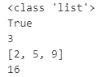

Experiment No.-2

**Aim:** Write the programs for Operators in Python

**Program Code:**

**# Special Operators**

**#### 1. Ternary Operator: Used for inline conditional expressions.**

x = 10

y = 20

min_value = x if x < y else y

print(min_value)# Output: 10

**Output:**



**Program Code:**

**#### 2. Operator Overloading: Operators like + can be overloaded to work with custom classes.**

class Vector:

    def __init__(self, x, y):

        self.x = x

        self.y = y

    def __add__(self, other):

        return Vector(self.x + other.x, self.y + other.y)

    def __repr__(self):

        return f"Vector({self.x}, {self.y})"

# Create vectors

v1 = Vector(1, 2)

v2 = Vector(3, 4)

# Add vectors

v3 = v1 + v2  # Uses __add__ method

# Print result

print(v3)  # Output: Vector(4, 6)

**Output:**



Experiment No.-3

**Aim:** Write the programs for Conditional Statements in Python

**Program Code:**

**# 1. if statement**

x = 10

if x > 5:

    print("x is greater than 5")

**Output:**



**Program Code:**

**# 2. if-else Statement**

x = 3

if x % 2 == 0:

    print("x is even")

else:

    print("x is odd")

**Output:**



**Program Code:**

**3. if-elif-else Statement**

x = 0

if x > 0:

    print("x is positive")

elif x < 0:

    print("x is negative")

else:

    print("x is zero")

**Output:**



**Program Code:**

**4. Nested if Statement**

x = 15

if x > 0:

  if x % 3 == 0:

    print("x is a positive number divisible by 3")

**Output:**



**Program Code:**

# Short-Hand (One-Liners)

# Short-Hand If

x = 10

if x > 5: print("x is greater than 5")

**Output:**



**Program Code:**

# Ternary operator

x = 10

result = "Even" if x % 2 == 0 else "Odd"

print(result)     # Output: Even

**Output:**



**Program Code:**

# Example of Common Use cases

## Checking Even or Odd

num = 7

if num % 2 == 0:

    print("Even")

else:

    print("Odd")

**Output:**



**Program Code:**

# Grading System

score = 85

if score >= 90:

  print("Grade: A")

elif score >= 80:

  print("Grade: B")

elif score >= 70:

  print("Grade: C")

elif score >= 60:

  print("Grade: D")

else:

  print("Grade: F")

**Output:**



**Program Code:**

**# Logical Operators in Conditions**

x = 10

y = 20

if x > 5 and y < 30:

    print("Both conditions are True")

**Output:**



**Program Code:**

**# Common Use-Cases**

## Checking Membership with in or not in:

fruits = ["apple", "banana", "cherry"]

if "banana" in fruits:

    print("Banana is in the list")

**Output:**



**Program Code:**

# Type checking:

x = 10

if isinstance(x, int):

    print("x is an integer")

**Output:**



Experiment No.-4

**Aim:** Write the programs for Loop Controls in Python

**Program Code:**

# For loop

# The for loop is used to iterate over sequences or iterables

# Iterating over a loop

numbers = [1,2,3]

for num in numbers:

    print(num)

# Iterating over a string

for char in "Python":

    print(char)

**Output:**

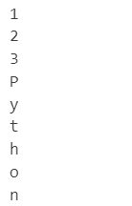

**Program Code:**

# while Loop

# The while loop repeats as long as a condition is True

count = 0

while count < 5:

    print(count)

    count += 1

**Output:**

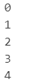

**Program Code:**

**# Built-in Functions for Iteration**

# 1. range()

# used to generate a sequence of numbers.

# Example: range(start, stop, step)

for i in range(1,5):

  print(i)  # output: 1,2,3,4

**Output:**

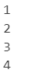

**Program Code:**

# 2. enumerate()

# Used to get the index and value during iteration.

fruits = ["apple", "banana", "cherry"]

for index, fruit in enumerate(fruits):

  print(f"Index {index}: {fruit}")

**Output:**

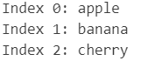

**Program Code:**

# 3. zip()

# Combines two or more sequences into a single iterable of tuples.

names = ["Alice", "Bob", "Charlie"]

ages = [25, 30, 35]

for name, age in zip(names, ages):

  print(f"{name} is {age} years old")

**Output:**

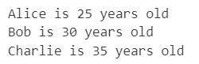

**Program Code:**

# 4. map()

# Applies a function to all items in an iterable.

numbers = [1, 2, 3]

squared = map(lambda x: x**2, numbers)

print(list(squared))  # output: [1, 4, 9]

**Output:**



**Program Code:**

# 5. filter()

# Filters items based on a condition

numbers = [1, 2, 3, 4]

evens = list(filter(lambda x: x % 2 == 0, numbers))

print(evens)  # output: [2, 4]

**Output:**



Experiment No.-5

**Aim:** Write the programs for User Defined Function, Module & Package in Python

**Program Code:**

**# A Simple Function**

def greet():

  print("Hello World")

greet()

**Output:**



**Program Code:**

**# Function With Parameters**

def greet_user(name):

  print(f"Hello, {name}!")

greet_user("Rohit")

**Output:**



**Program Code:**

**# Function With Return Values**

def add(a, b):

  return a + b

result = add(5, 3)

print(result)

**Output:**



**Program Code:**

**# User Defined Module**

import myModule

print(myModule.greet("Naveen"))

print(myModule.add(5, 3))

print(myModule.PI)

**Output:**

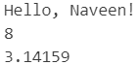

**Program Code:**

**# User Defined Module**

from myModule import greet, PI

print(greet("Alice"))

print(PI)

**Output:**



**Program Code:**

**# User Defined Package**

import mypackage

from mypackage import module1, module2

print(module1.add(5, 3))

print(module2.subtract(10, 4))

**Output:**



**Program Code:**

# Or import specific functions:

from mypackage.module1 import add

from mypackage.module2 import subtract

print(add(2, 2))

print(subtract(9, 5))

**Output:**



**Program Code:**

# Now, we can import functions directly from the package:

from mypackage import add, subtract

print(add(3, 7))  # Output: 10

print(subtract(15, 5))  # Output: 10

**Output:**



Experiment No.-6

**Aim:** Write the programs for CSV File Handling in Python

**Program Code:**

**#### Create and Write to example.csv**

import csv

# Create and write to the csv file

with open("example.csv", "w", newline="") as file:

  writer = csv.writer(file)

  # Writing a header row

  writer.writerow(["Name", "Age", "City"])

  # Writing data rows

  writer.writerow(["Alice", 25, "New York"])

  writer.writerow(["Bob", 30, "Los Angeles"])

  writer.writerow(["Charlie", 35, "Chicago"])

print("example.csv file created successfully!")

# Reading the newly created csv file

with open("example.csv", "r") as file:

  reader = csv.reader(file)

  for row in reader:

    print(row)  # Print each row from the file

**Output:**

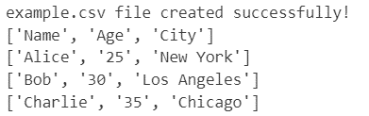

**Program Code:**

**## Using Pandas (Simpler for Data Analysis)**

import pandas as pd

# Reading a CSV File

df = pd.read_csv("example.csv")  # Dataframe object

print(df)

# Writing a DataFrame to a csv file

df.to_csv("output.csv", index = False)  # Avoids writing the index column

**Output:**

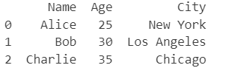

**Program Code:**

**## Code to append rows to example.csv**

import csv

# Append new rows to the csv files

with open("example.csv", "a", newline="") as file:

  writer = csv.writer(file)

  # Adding new rows

  writer.writerow(["David", 28, "San Francisco"])

  writer.writerow(["Eve", 32, "Houston"])

print("New rows added successfully")

# Verify the updated content of the csv files

with open("example.csv", "r") as file:

  reader = csv.reader(file)

  for row in reader:

    print(row)

**Output:**

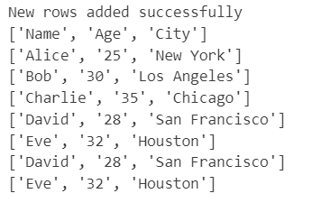

Experiment No.-7

**Aim:** Write the programs for Data Pre-processing in Python

**Program Code:**

# Import necessary libraries

import pandas as pd

import numpy as np

import matplotlib.pyplot as plt

import seaborn as sns

from sklearn.utils import shuffle

from sklearn.datasets import load_iris

#load data

data= load_iris()

df = pd.DataFrame(data.data, columns=data.feature_names)

print(df.describe())

**Output:**

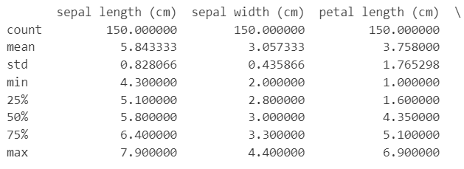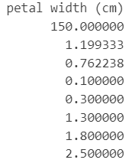

**Program Code:**

print(df.columns)

**Output:**

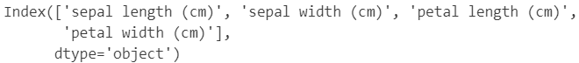

**Program Code:**

# Check the overall structure of the dataset

print(df.info())

**Output:**

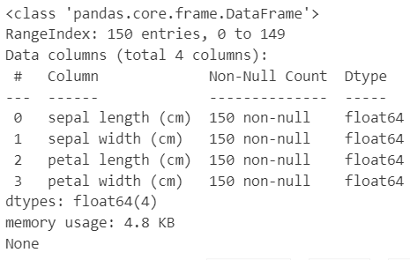

**Program Code:**

# Print initial shape and class distribution

print("Initial shape:", df.shape)

**Output:**



**Program Code:**

# Display first 5 rows

print("First 5 records:")

print(df.head())

# Display last 5 rows

print("\nLast 5 records:")

print(df.tail())

**Output:**

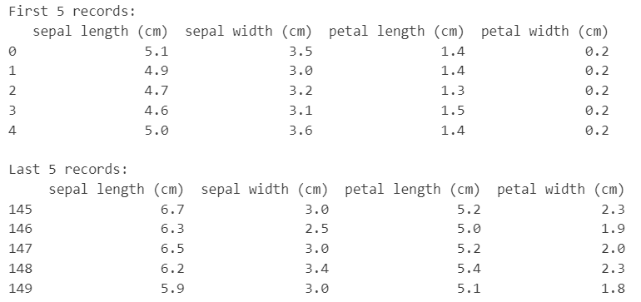

**Program Code:**

# Handle missing and non-numeric values

df.replace('-', np.nan, inplace=True)

before_drop_shape = df.shape

df.dropna(inplace=True)

print("Shape after dropping NaNs:", df.shape, "Dropped rows:", before_drop_shape[0] - df.shape[0])

# Drop duplicates and shuffle

df.drop_duplicates(inplace=True)

df = shuffle(df)

print("Shape after dropping duplicates:", df.shape)

**Output:**



**Program Code:**

# Visualizing the sepal length

plt.figure(figsize=(5,2.5))

sns.countplot(x='sepal length (cm)', data=df)

plt.title('sepal length')

plt.xticks(rotation=90)

plt.show()

**Output:**

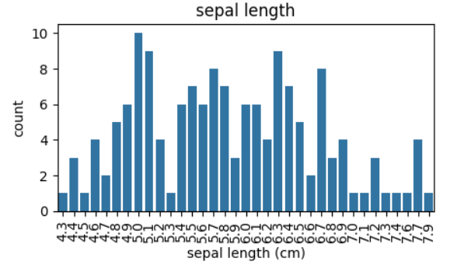

Experiment No.-8

**Aim:** Write a program for basic tags in HTML.

**Program Code:**

<html>

    <head>

        <title>HTML Assignment | Basic HTML Element</title>

        <meta name="desception" content="HTML Assignment One For Basic HTML Element">

        <meta name="keywords" content="HTML Assignment 1,HTML Lab Assignment 1,Html Pratical Assignment 1">

    </head>

<body leftmargin="100px" topmargin="50px">

    <center><h1>HTML Assignment 1</h1></center>

    <hr color="red"/>

    <p>

        it is my <b>First HTML</b>Assignment, And I am exited to learn HTML, annd I want to gain Knowledge of <b>web development</b>

    </p>

    <h2>Introduction to HTML</h2>

    <p align="justify">

        HTML (<i>Hypertext Markup language</i>) is used to create document on the <u>World Wide Wed.</u> <i>It is simply a collection of ceatain key words "tag" that is

            helpful in writing the document to be dispalyed using a browser on internet. </i>HTML was developed by <b>Tim Berners-Lee</b>in 1992.

    </p>

    <|--</xmp>-->

</body>

</html>

**Output:**

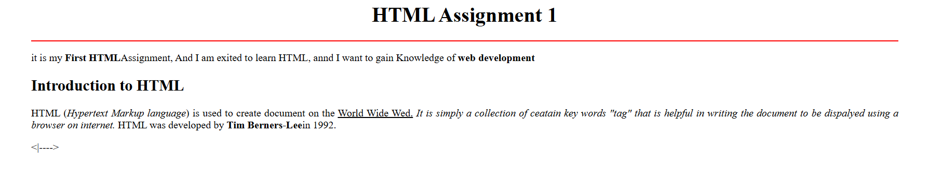

Experiment No.-9

**Aim:** Write a program for making your timetable in HTML.

**Program Code:**

<!DOCTYPE html>

<html>

    <head>

        <title>Time Table Of Data Sc.</title>

    </head>

    <body>

        <center><h1>Time Table (DS)</h1></center>

        <center>

            <table border="1" allign="center" width="80%" cellpadding="20px" cellspacing="2px">

                <tr>

                    <th>Day/Period</th>

                    <th>9:30 - 10:20</th>

                    <th>10:30 - 11:25</th>

                    <th>11:35 - 12:30</th>

                    <th>12:30 - 1:20</th>

                    <th>1:20 - 2:15</th>

                    <th>2:20 - 3:15</th>

                    <th>3:20 - 4:15</th>

                </tr>

                <tr>

                    <td style="text-align: center;">Monday</td>

                    <td rowspan="2" style="text-align: center;">Library</td>

                    <td style="text-align: center;">DSC 404</td>

                    <td style="text-align: center;">AEC 401</td>

                    <td rowspan="5" style="text-align: center;">LUNCH</td>

                    <td colspan="2" style="text-align: center;">DSC 402(Practical)</td>

                    <td style="text-align: center;">DSC 401</td>

                </tr>

                <tr>

                    <td style="text-align: center;">Tuesday</td>

                    <td style="text-align: center;">Tutorial</td>

                    <td style="text-align: center;">VAC 401</td>

                    <td style="text-align: center;">DSC 405</td>

                    <td colspan="2" style="text-align: center;">DSC 401(Practical)</td>

                </tr>

                <tr>

                    <td style="text-align: center;">Wednesday</td>

                    <td colspan="2" style="text-align: center;">DSC 404(Practical)</td>

                    <td style="text-align: center;">AEC 401</td>

                    <td style="text-align: center;">DSC 402</td>

                    <td style="text-align: center;">DSC 403</td>

                    <td style="text-align: center;">Seminar</td>

                </tr>

                <tr>

                    <td style="text-align: center;">Thursday</td>

                    <td style="text-align: center;">DSC 404</td>

                    <td style="text-align: center;">DSC 405</td>

                    <td style="text-align: center;">VAC 401</td>

                    <td style="text-align: center;">DSC 402</td>

                    <td style="text-align: center;">Library</td>

                    <td style="text-align: center;">DSC 401</td>

                </tr>

                <tr>

                    <td style="text-align: center;">Friday</td>

                    <td colspan="2" style="text-align: center;">DSC 405(Practical)</td>

                    <td style="text-align: center;">DSC 403</td>

                    <td style="text-align: center;">DSC 403</td>

                    <td colspan="2" style="text-align: center;">SPORTS</td>

                </tr>

            </table>

        </center>

    </body>

</html>

**Output:**

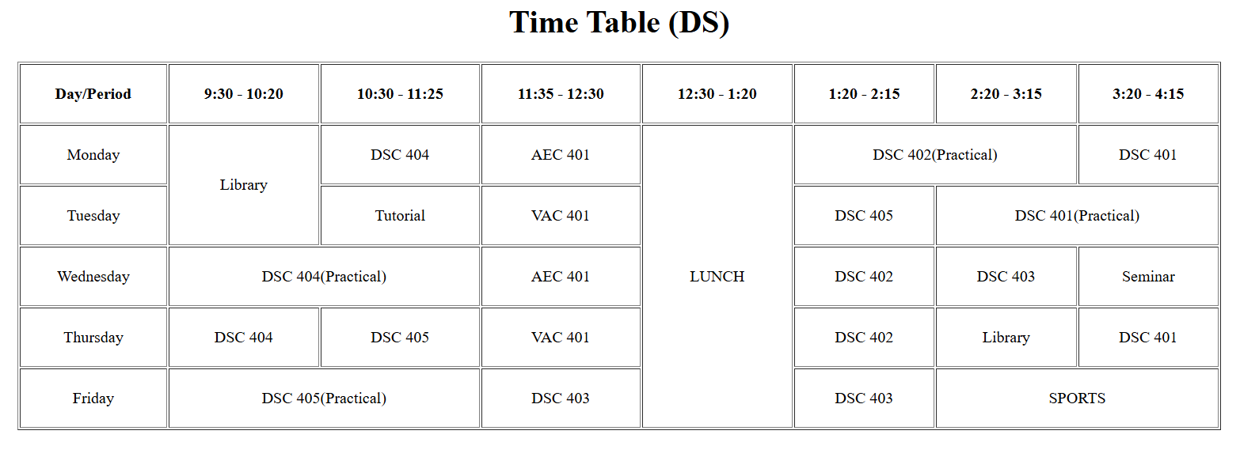

Experiment No.-10

**Aim:** Write a program for building college website using table tag in HTML.

**Program Code:**

<!DOCTYPE html>

<html>

    <head>

        <title>HTML Lab Assignment 5 - Table</title>

    </head>

    <body>

        <table width="90%" align="center" border="1" cellspacing="0" cellpadding="10px">

            <tr height="180px" bgcolor="orange">

                <td align="center" colspan="2">

                    <font size="7" color="white">Tribhuvan College</font>

                </td>

            </tr>

            <tr height="40px">

                <td colspan="2" bgcolor="gold">

                    <a href="#">Home</a> ||

                    <a href="about.html">About Us</a> ||

                    <a href="List Tag.html">Courses</a> ||

                    <a href="#">Exam Date</a> ||

                    <a href="#">Result</a> ||

                    <a href="#">Gallery</a>

                </td>

            </tr>

            <tr bgcolor="green" height="40px">

                <td colspan="2">

                    <marquee><b><i>

                        <font color="white">Welcome to Tribhuvan College Home Page</font>

                    </i></b></marquee>

                </td>

            </tr>

            <tr height="400px" bgcolor="gray">

                <td width="70%" valign="top">

                    <h1>Welcome to Tribhuvan College Home Page</h1>

                    <hr color="white"/>

                    <img src="logo.png" width="120px" align="left" hspace="30px" border="3"/>

                    <font color="white">

                        <p align="justify">

                            Tribhuvan College, Nalanda University Centre is situated in Neemrana, Rajasthan. The Centre has been established in a public-private-partnership and offers multidisciplinary Undergraduate programs of Nalanda University

                            Tribhuvan College encourages and promotes a research paradigm where experiential learning and innovative thoughts are encouraged. The College aims to be an interdisciplinary institution of higher learning incorporating strong regional, national, and international linkages to inculcate a high degree of specialization.

                        </p>

                        <p align="justify">

                            Tribhuvan College offers an array of courses dealing with the varied aspects of environmental science, data science, computer science, management, commerce, and economics, which form the backbone of achieving UN Sustainable Development Goals (SDGs). These courses focus on developing skilled human resources to tackle the environmental challenges faced by humanity.

                        </p>

                    </font>

                </td>

                <td width="30%" valign="top" align="center" bgcolor="skyblue">

                    <h2>Our Members</h2>

                    <hr color="red"/>

                    <marquee direction="up" height="300px">

                        <center>

                            <img src="man.png" width="120px"/><br/><b>Director</b><br/><br/>

                            <img src="woman.png" width="120px"/><br/><b>Manager</b><br/><br/>

                            <a href="me.html"><img src="leader.png" width="120px"/><br/><b>This is Me</b><br/><br/></a>

                        </center>

                    </marquee>

                </td>

            </tr>

            <tr height="50px" bgcolor="orange">

                <td colspan="2" align="center">

                    Copyright &copy; 2022 All Rights Reserved

                </td>

            </tr>

        </table>

    </body>

</html>

**Output:**



Experiment No.-11

**Aim:** Write a program for making Application Form using HTML, php and MySQL.

**Program Code:** HTML Part

<!DOCTYPE html>

<html>

<head>

    <title>APPLICATION FORM</title>

</head>

<body leftmargin="200px">

    <center><h3>APPLICATION FORM</h3></center>

    <form action="submit_form.php" method="POST" enctype="multipart/form-data">

        <fieldset>

            <legend>Personal Details</legend>

            <table width="100%" cellpadding="10px">

                <tr>

                    <td>Applicant's full name</td>

                    <td>

                        <select>

                            <option>--Select--</option>

                            <option>Mr.</option>

                            <option>Ms.</option>

                            <option>Others</option>

                        </select>

                        <input type="text" size="20" name="applicant_name" />

                    </td>

                    <td>Care Of</td>

                    <td>

                        <label>Parents</label><input type="radio" name="care" value="Parents" checked />

                        <label>Guardian</label><input type="radio" name="care" value="Guardian" />

                    </td>

                </tr>

                <tr>

                    <td>Father's Name</td>

                    <td>

                        <select disabled>

                            <option>Mr.</option>

                        </select>

                        <input type="text" size="20" name="father_name" />

                    </td>

                    <td>Mother's Name</td>

                    <td>

                        <select disabled>

                            <option>Mrs.</option>

                        </select>

                        <input type="text" size="20" name="mother_name" />

                    </td>

                </tr>

                <tr>

                    <td>Gender</td>

                    <td>

                        <label>Male</label><input type="radio" name="Gender" value="Male" />

                        <label>Female</label><input type="radio" name="Gender" value="Female" />

                        <label>Others</label><input type="radio" name="Gender" value="Others" />

                    </td>

                    <td>Date of Birth</td>

                    <td><input type="date" name="dob" /></td>

                </tr>

                <tr>

                    <td>Marital Status</td>

                    <td>

                        <select name="marital_status">

                            <option>--Select--</option>

                            <option>Single</option>

                            <option>Married</option>

                            <option>Divorced</option>

                            <option>Widowed</option>

                        </select>

                    </td>

                    <td>Category</td>

                    <td>

                        <select name="category">

                            <option>--Select--</option>

                            <option>General</option>

                            <option>OBC</option>

                            <option>SC</option>

                            <option>ST</option>

                        </select>

                    </td>

                </tr>

                <tr>

                    <td>Handicapped </td>

                    <td><label>No</label><input type="radio" name="Handicapped" value="No" checked/>

                    <label>Yes</label><input type="radio" name="Handicapped" value="Yes"/></td>

                    <td>Ex-Serviceman </td>

                    <td><label>No</label><input type="radio" name="Serviceman" value="No" checked/>

                    <label>Yes</label><input type="radio" name="Serviceman" value="Yes"/></td>

                </tr>

                <tr>

                    <td>EWS </td>

                    <td><label>No</label><input type="radio" name="EWS" value="No" checked/>

                    <label>Yes</label><input type="radio" name="EWS" value="Yes"/></td>

                    <td>Religion </td>

                    <td>

                        <select name="religion">

                            <option>--Select--</option>

                            <option>Hindu</option>

                            <option>Muslim</option>

                            <option>Jain</option>

                            <option>Christianity</option>

                        </select>

                    </td>

                </tr>

            </table>

        </fieldset>

        <fieldset>

            <legend>Contact Details</legend>

            <table width="100%" cellpadding="10px">

                <tr>

                    <td>Mobile Number</td>

                    <td><input type="tel" name="mobile" /></td>

                    <td>Email ID</td>

                    <td><input type="email" name="email" /></td>

                </tr>

                <tr>

                    <td>Address Line 1</td>

                    <td><input type="text" name="address1" /></td>

                    <td>Address Line 2</td>

                    <td><input type="text" name="address2" /></td>

                </tr>

                <tr>

                    <td>City</td>

                    <td><input type="text" name="city" /></td>

                    <td>State</td>

                    <td>

                        <select name="state">

                            <option>--Select--</option>

                            <option value="Andhra Pradesh">Delhi</option>

                            <option value="Maharashtra">Haryana</option>

                            <option value="Delhi">Rajasthan</option>

                            <option value="Tamil Nadu">West Bengal</option>

                        </select>

                    </td>

                </tr>

                <tr>

                    <td>Pin Code</td>

                    <td><input type="text" name="pin_code" /></td>

                </tr>

            </table>

        </fieldset>

        <fieldset>

            <legend>Identification Details</legend>

            <table>

                <tr>

                    <td>Aadhar Card Number</td>

                    <td><input type="text" name="aadhar" maxlength="12" /></td>

                    <td>PAN Card Number</td>

                    <td><input type="text" name="pan" maxlength="9" /></td>

                </tr>

                <tr>

                    <td>Upload Photo</td>

                    <td><input type="file" name="photo" /></td>

                    <td>Upload Signature</td>

                    <td><input type="file" name="signature" /></td>

                </tr>

            </table>

        </fieldset>

        <br/>

        <center>

            <input type="submit" value="Submit" />

            <input type="reset" value="Reset" />

        </center>

    </form>

</body>

</html>

**Output:**

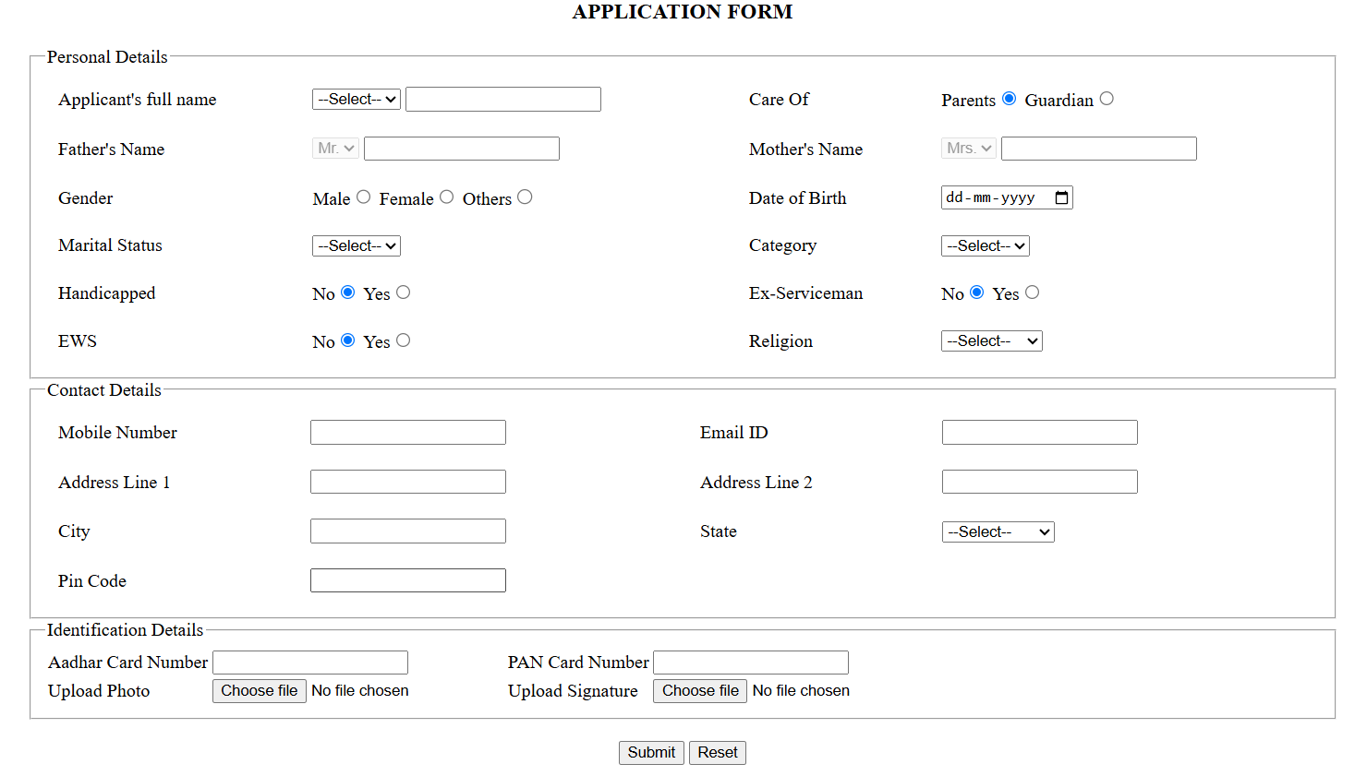

**Program Code:** Php Part

<?php

$servername = "localhost";

$username = "root"; // Change this if your MySQL username is different

$password = "12345"; // Set your MySQL password if any

$dbname = "student";

// Create connection

$conn = new mysqli($servername, $username, $password, $dbname);

// Check connection

if ($conn->connect_error) {

    die("Connection failed: " . $conn->connect_error);

}

// Retrieve form data

$full_name = $_POST['applicant_name'];

$care_of = $_POST['care'];

$father_name = $_POST['father_name'];

$mother_name = $_POST['mother_name'];

$gender = $_POST['Gender'];

$dob = $_POST['dob'];

$marital_status = $_POST['marital_status'];

$category = $_POST['category'];

$handicapped = $_POST['Handicapped'];

$ex_serviceman = $_POST['Serviceman'];

$ews = $_POST['EWS'];

$religion = $_POST['religion'];

$mobile_number = $_POST['mobile'];

$email = $_POST['email'];

$address_line1 = $_POST['address1'];

$address_line2 = $_POST['address2'];

$city = $_POST['city'];

$state = $_POST['state'];

$pin_code = $_POST['pin_code'];

$aadhar_number = $_POST['aadhar'];

$pan_number = $_POST['pan'];

// Handle file uploads

$photo_path = "uploads/" . basename($_FILES["photo"]["name"]);

$signature_path = "uploads/" . basename($_FILES["signature"]["name"]);

move_uploaded_file($_FILES["photo"]["tmp_name"], $photo_path);

move_uploaded_file($_FILES["signature"]["tmp_name"], $signature_path);

$sql = "INSERT INTO application_form (full_name, care_of, father_name, mother_name, gender, dob, marital_status, category, handicapped, ex_serviceman, ews, religion, mobile_number, email, address_line1, address_line2, city, state, pin_code, aadhar_number, pan_number, photo_path, signature_path)

        VALUES ('$full_name', '$care_of', '$father_name', '$mother_name', '$gender', '$dob', '$marital_status', '$category', '$handicapped', '$ex_serviceman', '$ews', '$religion', '$mobile_number', '$email', '$address_line1', '$address_line2', '$city', '$state', '$pin_code', '$aadhar_number', '$pan_number', '$photo_path', '$signature_path')";

if ($conn->query($sql) === TRUE) {

    echo "<script>alert('Record submitted successfully!'); window.location.href='ApplicationFormNew.html';</script>";

} else {

    echo "Error: " . $sql . "<br>" . $conn->error;

}

$conn->close();

?>

**Program Code:** MySQL Part

CREATE DATABASE STUDENT;

USE STUDENT;

CREATE TABLE application_form (

id INT AUTO_INCREMENT PRIMARY KEY,

full_name VARCHAR(255),

care_of VARCHAR(50),

father_name VARCHAR(255),

mother_name VARCHAR(255),

gender VARCHAR(10),

dob DATE,

marital_status VARCHAR(50),

category VARCHAR(50),

handicapped VARCHAR(10),

ex_serviceman VARCHAR(10),

ews VARCHAR(10),

religion VARCHAR(50),

mobile_number VARCHAR(20),

email VARCHAR(255),

address_line1 TEXT,

address_line2 TEXT,

city VARCHAR(100),

state VARCHAR(100),

pin_code VARCHAR(10),

aadhar_number VARCHAR(20),

pan_number VARCHAR(20),

photo_path VARCHAR(255),

signature_path VARCHAR(255)

);

**Output:**

